San Diego Mesa College Name_________________________
Physics 195A Lab Report Date __________Time___________
Partners ______________________

TITLE: Rotational Dynamics ______________________________
______________________________
______________________________

Objective: 1. To test the experimental validity of the parallel axis theorem.

- To determine the relationship between the rotational inertia and the mass distribution of an object.

- To test the theoretical equations for rotational inertia by comparison with experimental values.

Theory: I. The dynamic equation for rotation of a rigid body about a fixed axis, A.

$\sum{{\vec{τ}}_{\text{ext}}}=I_{A} \vec{α}$

- The definition of angular acceleration;

$$α=\frac{dω}{\text{dt}}=\frac{d^{2}θ}{{\text{dt}}^{2}}$$

- The definition of torque (with diagram);

$${\vec{τ}}_{o}=\vec{R}x\vec{F},\left|\vec{τ}\right|=\text{RF}\text{sin}Θ$$
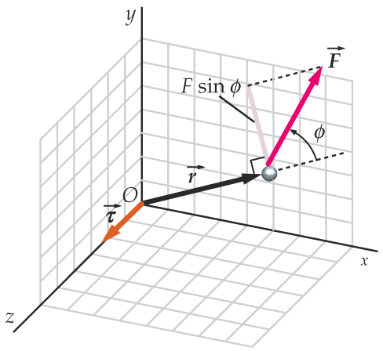
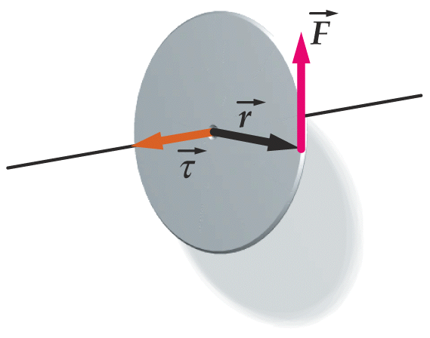

IV. Derive the expression $I=\sum_{i=1}^{n}{m_{i}}r_{i}^{2}$ from the rotational kinetic energy of an object.
(hint: v = ωr)
Your derivation:

V. Theoretical relationships for the rotational inertia of various objects;

Solid cylinder; There are two identical black cylinders in this lab.

$I_{\text{cm}}=\frac{{\text{Mr}}^{2}}{2}$

Hollow cylinder; $I_{\text{cm}}=\frac{M}{2}(R_{\text{outer}}^{2}+R_{\text{inner}}^{2})$

Square bar; $I_{\text{cm}}=\frac{M}{\text{12}}\left[A^{2}+B^{2}\right]$

Parallel Axis Theorem; $I_{\text{PA}}=I_{\text{cm}}+{\text{MD}}^{2}$

Equipment: Rotational Air Tables Electronic balance Ringstand with 30cm rod

Box of discs for RAT Tube clamp Air regulator

Box of accessories for RAT Ethanol in 250ml bottle Tissues (for cleaning discs)

Transformer for RAT Masking Tape Spool of thread

Plumb bob Vernier calipers Scissors

Meter stick 12” ruler

Setup:

Procedure: A. Check to make sure that the clamp on the bottom hose is open (see Fig. 1). When the clamp is open and the hose is not crimped, the top disk will rotate when pushed but the bottom disk will not move.

- Level the Air table using the “bubble level” provided.

- Connect the tube from the air regulator to the compressed air supply on the lab table as per Fig. 1.

- Carefully place the steel “base” disk (see Fig. 2) on the spindle of the air table. To do this, hold the disk by the edges and parallel to the table and line up the center hole of the disk with the spindle and slowly lower the disk onto the spindle. *The base disk has an orange label on the bottom of the disk.

- Use a soft tissue and a few drops of alcohol to clean the top of the base disk and the bottom of the aluminum disk before you place it on the spindle on top of the steel “base” disk. DO NOT ROTATE DISKS WITHOUT AIR FLOWING THROUGH THE APPARATUS!

- Set the switch on the top of the counter housing to read the bars/second for the TOP disk.

PART I: ROTATIONAL INERTIA AND MASS DISTRIBUTION

- Refer to Fig. 2: Remove the “thread holder”, the VRM (without the black cylinders) from the “parts box” and the small “torque pulley” and 10g hooked mass from the disk box. Tie one end of the thread from the spool through the hole in the thread holder and put the thread holder in the recessed side of the torque pulley Pull the thread through the slot in the pulley and place this assembly on the top disk so that the shaft of the VRM is lined up with the hole in the middle of the pulley. With the VRM and pulley screwed to the disk, pull the thread over the “air pulley” and down to about a few centimeters past the length to the floor. Cut the end of the thread on the floor and tie the 10g mass to it. Put the 10g mass on the table.

- The “Optical Reader” counts the number of black bars (on the edge of the disks) that pass by it for one second and then displays that count for the next second but is not counting while displaying. Therefore, do not use; 1) the first bars/s data or 2) the last reading when the mass reaches its lowest point and starts back up.

- Record measurements for the mass of the hanging mass, and the diameter of the small torque pulley (* measured from the ‘waist’ of the pulley – were the string wraps around it *) on the data table. Measure the mass of each black cylinder, and record the average of the two masses as the ‘cylinder mass’ on your data table. Repeat this ‘averaging’ technique for the ‘cylinder diameter’ and record this on your data table.

- Make sure that the hose is well attached to the bench air outlet and turn it on—slowly—until the gauge on the regulator reaches 8 to 10 psi. You may have to readjust the air pressure throughout the experiment to maintain a reading of 8 to 10 psi

- Place both black cylinders on the axis of the VRM holder and take measurements (by letting the hanging mass fall toward the ground) to determine the magnitude of the angular acceleration, α , of the combined top disk, torque pulley, VRM holder, and black cylinders. This measurement will give you I_{(D = 0)} .

If you have room in your data table, repeat each α measurement.

- Slide the black cylindrical masses back onto the VRM holder as shown in the diagram below. For your first measurement, set D = 3.0 cm. Repeat the procedure of letting the hanging mass fall to record data that will allow you to determine I_{(D ≠ 0)}.

- Continue to move the cylinders away from the hub in 1.0 cm increments and take and record data up to D = 9.0 cm.

- The Moment of Inertia of the system changes as you change the distance, D, from the hub axis. Determine ΔI = I_{(D ≠ O)} − I_{(D = O)} for each data set and record it in your analysis table.

Data: PART I:

Hanging mass: _______ kg Cylinder mass: ________kg
Pulley diameter:____________________ Pulley radius:________________________

DATA TABLE TO DETERMINE THE CHANGE IN MOMENT OF INERTIA OF THE SYSTEM

AS A FUNCTION OF THE DISTANCE, D.
D = 0.0 cm |  | D = 3.0 cm |  | D = 4.0 cm |  | D = 5.0 cm
Bars / s | Δ Bars / s | Bars / s | Δ Bars / s | Bars / s | Δ Bars / s | Bars / s | Δ Bars / s
 | AVG = |  | AVG = |  | AVG = |  | AVG =

DATA: PART I: (continued)

D = 6.0 cm |  | D = 7.0 cm |  | D = 8.0 cm |  | D = 9.0 cm
Bars / s | Δ Bars / s | Bars / s | Δ Bars / s | Bars / s | Δ Bars / s | Bars / s | Δ Bars / s
 | AVG = |  | AVG = |  | AVG = |  | AVG =

Analysis:
PART I:
- Calculate the magnitude of the constant torque exerted by the hanging mass on the small torque pulley (and thus on the top disk and VRM).

For small accelerations, T ≈ mg, so

$\left|τ\right| ≃ r (\text{mg})$ = _______________ = a constant

2. Calculate the average angular acceleration (magnitude) using the average Δbars/s.

α_{ave} = Δω/t = [(ΔBars/s)(.0314 rad/Bar)]/2s

3. Calculate the rotational inertia I corresponding to various D values. (Show a sample calculation including units.)

$$\text{I } \text{= } \frac{τ}{α} \text{ =}$$

4. ΔI = I_{(D ≠ O)} - I_{(D = O)}

D | τ | α | I_{(D≠0)} | I_{(D=0)} | ΔI
cm | Nm rad | rad / s² | kg m² | kg m² | kg m²
0.0
3.0
4.0
5.0
6.0
7.0
8.0
9.0

GRAPHS: Use 2-cycle log-log paper to plot the change in rotational inertia of the system as a function of the distance, D, of the cylinders from the hub.

ANALYSIS:
- Write the relationship between the change in rotational inertia of the system and the distance, D, of the cylinders from the hub, as given by the graph of ΔI = f(D). Use the appropriate constants from the graph, and include proper units for the proportionality constant. Your expression should have the form: ΔI = k D^{n} .

- How is the constant k related to the mass of the black cylinder?

- Use the results of your graph to determine the inertial mass of the black cylinder. Compare this with the gravitational mass (by giving a % difference).

- Use the equation written above in part A to predict the change in rotational inertia of the system when the cylinders are moved from D = 0 to D0 for a value of D other than a value measured in the experiment. Show the equation, substitution (including units) and the solution:

- In part D above you just used your experimental expression ΔI = f(D) to calculate ΔI for some value of D. Now use the theoretical relation ΔI = 2MD² to determine the difference in rotational inertia of the two cylindrical masses using that same value of D. Compare this theoretical prediction with the value calculated in part D.

PART II: EXPERIMENTAL TECHNIQUES;

Techniques similar to those used in Part I are used to dynamically determine the rotational inertia of various objects. Attach the small torque pulley to the disk using a solid, black-capped thumbscrew. Take measurements (by allowing the hanging mass to fall) to determine the moment of inertia I for the disk + pulley system. Then, after this data is recorded, attach the square bar to the small torque pulley using a red-capped thumbscrew and repeat the measurement process to determine moment of inertia I for the disk + pulley + square bar.

DATA:

DISK + PULLEY |  | DISK + PULLEY + SQUARE BAR  M_{bar} = a = b =
Bars / s | Δ Bars / s | Bars / s | Δ Bars / s
 | AVG = |  | AVG =

PART II: EXPERIMENTAL TECHNIQUES (cont.)

Attach the thin square aluminum plate to the small torque pulley with a gray-capped thumbscrew. The protrusions on the bottom of the small hollow cylinder mate with the holes in the aluminum plate. Repeat the previous procedure to find the moment of inertia I of the small black hollow cylinder.

DATA:

DISK + PULLEY + PLATE |  | HOLLOW CYLINDER + DISK + PULLEY + PLATE  M_{hollow cyl} = d_{inner} = d_{outer} = r_{i} = r_{o} =
Bars / s | Δ Bars / s | Bars / s | Δ Bars / s
 | AVG = |  | AVG =

ANALYSIS: PART II

Use the experimental measurements and the rotational form of the dynamic equation to calculate the
rotational inertia of the square bar.

Ι_{aluminum disk + pulley} = Ι₁

Ι₁ =

Ι_{Square bar + disk + pulley} = Ι₂

Ι₂ =

Ι_{Square bar} = Ι₂ − Ι₁

Use the appropriate theoretical equation to calculate the rotational inertia of the square bar.

Ι_{Square bar} = $\frac{M}{\text{12}}\left[a^{2}+b^{2}\right]=$

Compare (% difference) the experimental and theoretical values for the rotational inertia of the square bar.

Use the experimental measurements and the rotational form of the dynamic equation to calculate the
rotational inertia of the hollow cylinder.

Ι_{aluminum disk + pulley + plate} = Ι₁

Ι₁ =

Ιhollow cylinder + disk + pulley + plate = Ι₂

Ι₂ =

Ι_{hollow cylinder} = Ι₂ − Ι₁

Use the appropriate theoretical equation to calculate the rotational inertia of the hollow cylinder.

Ι_{hollow cylinder} = $\frac{M}{2}(R_{\text{outer}}^{2}+R_{\text{inner}}^{2})$ =

Compare the experimental and theoretical values for the rotational inertia of the hollow cylinder.

Conclusion and summary of results:

