San Diego Mesa College
Name_________________________

Group #_______

Time_______ Date______________
Partners ___________________________

___________________________

___________________________
Physics 195 Lab Report

TITLE: CENTRIPETAL FORCE &
NEWTON'S SECOND LAW

OBJECTIVE: To determine if Newton's Second Law is a valid description of the force acting on a mass moving in a circular path at a constant speed.

THEORY: The magnitude of the velocity (the speed) of a particle in uniform circular motion is constant for a circular path of constant radius. The centripetal acceleration of the particle is given by:

$$a_{c }= \frac{v^{2}}{r}$$

where v is the linear speed and r is the radius of the circle.

If Newton's Second Law is valid for circular motion, the inertial mass of the particle can be found by measuring the centripetal acceleration as a function of the centripetal force.

$\sum{{\vec{F}}_{c} = m {\vec{a}}_{c}}$

Newton's Second Law is then tested by comparing the inertial mass of the particle with an independent measurement of the gravitational mass.

In a similar manner, constant resultant force acting on the particle can be determined by changing the inertial mass and measuring the centripetal acceleration. The force predicted by the relationship can then be compared with the known applied force.

Mass has been defined as the measure of inertia in standard units of the kilogram.

Force has been defined, in Newtons, as the push or pull necessary to cause the velocity of a one-kilogram mass to change at the rate of one meter per second per second.

Procedure:

PART I: Centripetal acceleration a_{c} as a function of centripetal force F_{c} for a rotating bob.

You will be measuring the centripetal acceleration a_{c} as a function of centripetal force F_{c} for a rotation bob using three different springs at two different radii. The force exerted by the spring depends upon the amount that it is stretched, and therefore must be measured for each spring and each radius used in the experiment. Thus, you will have a total six data points to graph.

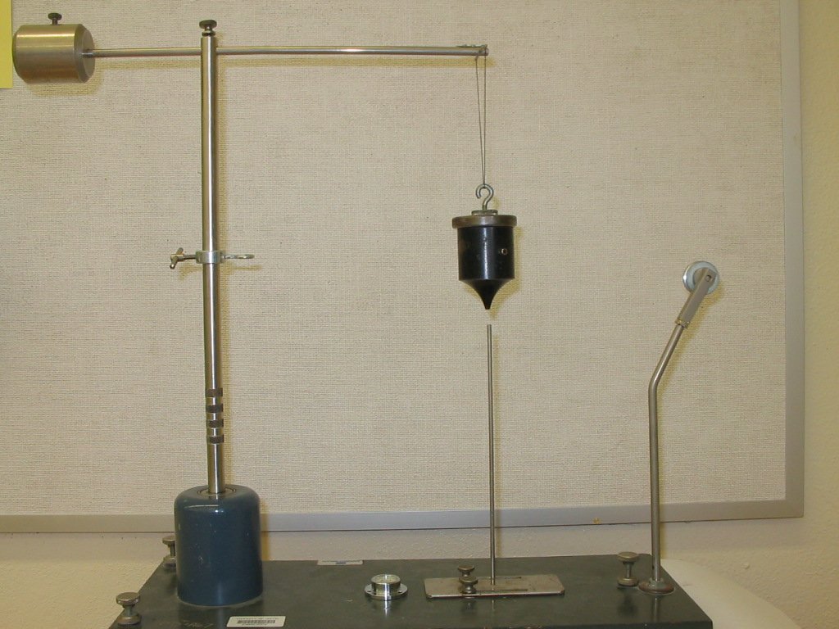

1. Firmly attach a 100-gram mass to the top of the black bob and set up the apparatus as shown in figure 1. (Both masses together will be referred to as the ‘bob’). Use a bubble-level to level your apparatus. Set the radius marker at its smallest radius. Be sure that the upper arm and the radius marker are adjusted such that the bob is directly over the marker when the bob hangs straight down (see figure 1.). (It will be necessary to readjust the upper arm when the marker is changed to a new radius).
r

Fig. 1

2. Measure and record the radius r from the center of the axis of rotation to the tip of the marker. Measure the mass of the bob (w/ the 100-gram mass) on the precision balance and record it in your data table as M_{bob}.

The springs will be labeled as:

Weakest spring - #1
Medium spring - #2
Strongest spring - #3

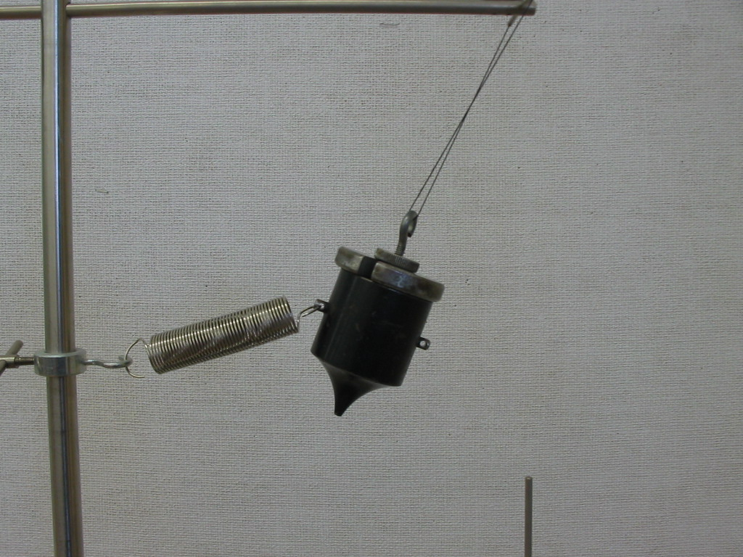
3. Attach the spring #1 to the apparatus as in figure 2. Make sure that the spring is horizontally oriented when the bob is swung around in a circle and passing over the tip of the marker.
Continue to rotate the bob so that it passes directly over the marker. Using a timer, record the period of revolution of the bob. The period is the time required for one revolution, and is found by measuring the total time for 20 revolutions to average out speed variations, and dividing by 20.
Record the total time and period in your data table.

Fig. 2

Since the centripetal acceleration of the rotating bob is $a_{c }= \frac{v^{2}}{r}$, you will first have to calculate the speed v of the bob:

$v= \frac{\text{distance}}{\text{time}} = \frac{2 π r}{t}$, where t is the period.

4. Remove spring #1 and replace with spring #2 and repeat step 3.

- Remove spring #2 and replace with spring #3 and repeat step 3.
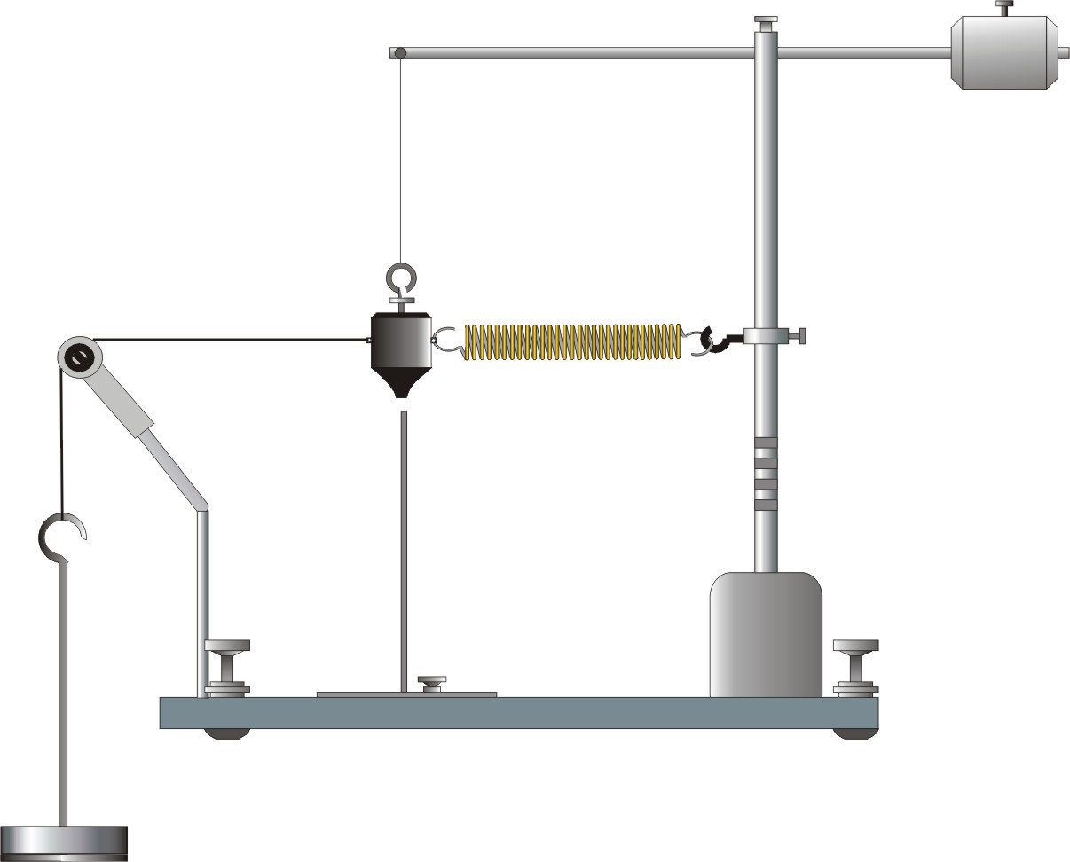
6. Connect a string to the bob and mass-hanger as shown in figure 3. You will measure the spring force by adjusting the weight (mg) until the bob is just over the marker. This is a static measurement, referred to as the spring calibration in the data table. Continue to add mass to the hanger until the bob is directly aligned over the radius marker. Record the hanging mass and weight (mg) in your data table.

Fig. 3

7. Repeat this spring calibration in step 6 for the other two springs.

8. Do not cut the string (leave the string attached to the bob), but remove the spring and mass hanger. Now change the radius marker to the largest possible radius. Be sure that the upper arm and the radius marker are adjusted such that the bob is directly over the marker when the bob hangs straight down (see figure 1.)

9. Repeat step 6 in order to measure the spring calibration force for each spring at the new larger radius. Record all measurements in your data table.

PART II: Centripetal acceleration a_{c} as a function of reciprocal mass M_{bob}.

Using the weakest spring (constant force) fixed at the smaller radius, vary the mass of the bob in 50-gram
increments and repeat the period measurements of Part I. Because the incremental mass change is small,
extreme care must be taken to assure that accurate measurements are taken. Increase the number of
revolutions timed to at least 40. Record all measurements in your data table.

DATA:
SPRING CALIBRATION: |  | Sample Calculations:

Spring | Radius  (meters) | hanging  mass (kg) | spring  force (N) = mg
Weak 1s | s
Medium 2s | s
Strong 3s | s
Weak lL | L
Medium 2L | L
Strong 3L | L
PART I | M_{bob} = __________grams
Spring force  (from above)  (N) | radius (m) | # of rev | total time | period (s) | speed(m/s) | a_{c} (m/s²)
Weak |  | 20
Medium |  | 20
Strong |  | 20
Weak |  | 20
Medium |  | 20
Strong |  | 20
PART II | Constant spring force =
mass (kg) | 1/mass | # of rev | total time | period (s) | speed (m/s) | a_{c} (m/s²)
 |  | 40
 |  | 40
 |  | 40
 |  | 40
 |  | 40

Analysis:

PART I: Centripetal acceleration a_{c} as a function of centripetal force F_{c} for a rotating bob.

GRAPHS: Construct a graph of the centripetal acceleration of the bob as a function of the net centripetal force on it.
(Insert data plots on appropriate graph paper here.)

EXPERIMENTAL THEORETICAL

Determine the slope of the first graph and Write Newton’s Second Law in the form
write the equation of your line. suggested by your graph.
Ignore any intercept.

Do not forget proper units!

IF the theory is correct THEN the proportionality constant (the slope) relating the variables of the
first graph should be physically interpreted as …(write it out in sentence form).

Determine the inertial mass of the rotating bob from the slope of the your graph.

Compare ( % difference ) the inertial mass of the bob with its gravitational mass as measured on
the electronic balance.

$$\text{\%} \text{Difference} =\frac{\left| ?_{\text{meas}}−?_{\text{pred}} \right|}{?_{\text{meas}}}∗ \text{100}$$

Analysis: (cont.)

PART II: Centripetal acceleration a_{c} as a function of reciprocal mass M_{bob}

GRAPHS: Construct a graph of the centripetal acceleration of the bob as a function of the reciprocal mass of the bob M_{bob}.
(Insert data plots on appropriate graph paper here.)

EXPERIMENTAL THEORETICAL

Determine the slope of the first graph and Write Newton’s Second Law in the form
write the equation of your line. suggested by your graph.
Ignore any intercept.

Do not forget proper units!

IF the theory is correct THEN the proportionality constant (the slope) relating the variables of the
first graph should be physically interpreted as …(write it out in sentence form).

Determine the constant centripetal force on the rotating bob from the slope of the your graph.

Compare ( % difference ) this centripetal force on the bob with the value you measured in Part I.

$$\text{\%} \text{Difference} =\frac{\left| ?_{\text{meas}}−?_{\text{pred}} \right|}{?_{\text{meas}}}∗ \text{100}$$

Conclusion and Summary of Results:

