San Diego Mesa College Name_________________________
Physical science 101 Date __________Time___________
Lab Report Partners ______________________
______________________________

TITLE: GEOLOGICAL MODELS

Objective: The purpose of these models is to show typical topographic forms and their relation to underlying geologic structures, to help in identifying and understanding geological structures and geological processes that produced them. After studying these models, we should be encouraged to observe the landscape about us more carefully and hopefully be better able to recognize the forces that have produced these topographic features.

Theory: Great forces that have been at work for hundreds of millions of years have shaped the crust of the earth. These forces are still at work and will continue as long as the earth exists. All geologic processes can be classified under three main categories: Diastrophism, Volcanism, and Gradation.
Diastrophism is any deformation of the earth’s crust. Lands and sea basins are uplifted or depressed. Continents, plateaus, and plains are uplifted. In places, the crust is folded and faulted to form mountains.
Volcanism is the process by which magma (molten material) is emplaced in the earth’s crust to cool and crystallize as intrusive igneous rock, such as granite; or by which the molten material comes to the surface as lava in volcanoes or along fissures.
Gradation is the wearing down or building up of the crust. The wearing down – erosion- is by water flowing over the lands or in streams; by water dissolving soluble rocks below the surface; by winds; by ice of glaciers; and by waves of seas or lakes. The building up is by deposition of the eroded material as alluvium by rivers and streams; sand and dust by wind; unsorted debris by glaciers; and most important of all, by deposition in seas of materials eroded from the lands or of materials formed by hard parts of animals and plants.
Erosion and deposition- gradation- eventually would bring the earth to an even surface, but diastrophism uplifts part of the earth’s surface from time to time so that gradation can begin again. The positions of seas and continental shelves thus change and old lands emerge. Along shores, coastal plains are formed when coasts are drowned and river valleys become bays.

Equipment: The Geology Models will be provided in class. Each model contains an index key along the edges with numbers running east and west, and letters north and south.

Procedure: For all eight geological models, pay attention to: geological structures, types of rocks, arrangement of layers, and ALL given definitions. Read the description associated to the geological model that you choose, identify all topographic features described in these instructions, and answer to the question(s) (if any). Take a minimum of three tests out of eight available. Your score for this specific lab will be based on these answers.

MODEL 1: COASTLINE OF SUBMERGENCE

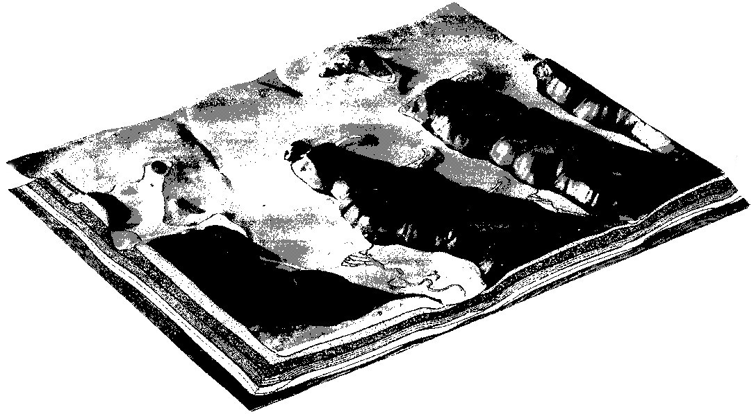
LEGEND
 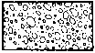  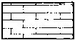
SANDSTONE CONGLOMERATE SHALE LIMESTONE

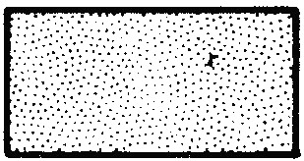 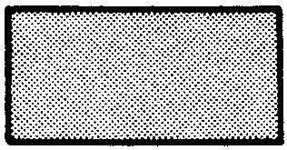 
SEDIMENTS LAVA ASH

This model represents a sinking coastline. As the land slowly sank, the sea filled the valleys to form bays. Former ridges now protrude into the sea as promontories. Seaward from the northernmost promontory is an island that was a hill on the old ridge, which has been isolated by drowning of the lower land between the hill and the higher part of the ridge. In addition, this model represents a coastline that is constantly changing, and the forces of erosion and deposition are working to produce these changes. The sea is the most dramatic agent of erosion, constantly tearing away at the promontories, to produce cliffed headlands. Remnants of the original land are steep-sided, resembling chimneys, called stacks. On the seaward side of the islands, the force of the waves has produced steep cliffs, similar to those on the promontories. As the waves came in from the sea, they are usually parallel to the trend of the coast. Waves hit he high land around the promontories first, bend around it, concentrating energy on the end of the promontory and as a result, most of the erosion occurs here.

The refraction of the waves causes them to bend around the promontory causing the eroded material to be moved along the sides of the promontory towards the head of the embayment. The depositional features which have resulted from these processes are as follows: Mid-bay Bar (8) – Deposited here as the refracted waves carried material towards the head of the embayment where they lost most of their force. Cuspate Foreland (13) – Waves and current action have carried the materials seaward and deposited them in this triangular form. Looped Bar (5) – The action of the waves which were refracted around the island, produced longshore drift along each side of the island. Longshore drift carried sand along each side and toward the back of the island and the two streams of sand along each side and toward the back of the island and the two streams of sand met and produce a horseshoe shaped or “looped” bar. Simple Recurved Spit (7) and Compound Recurved Spit (6) – Waves erode the end of the promontories and longshore currents carry the sand northward into deeper water to form spits. Spits are usually recurved because of wave action. Tombolo (16) – The material eroded from the cliffed headlands of the island has been swept from the island toward the land. This material has formed a deposit joining the island to the land to form a “tied island.”
The many streams that occur in the valleys of the promontories represent another agent of erosion. These streams tend to deepen their beds as the water rushes to the sea. Submarine canyons may also be found along the continental shelf. These may be ancient drowned river valleys or may have been formed by underwater currents in ways still being studied by marine geologists.

Question 1: What is happening to the seaward of the offshore islands?

Question 2: What deposits are built up by material deposited from refracted waves?

MODEL 2: VOLCANISM
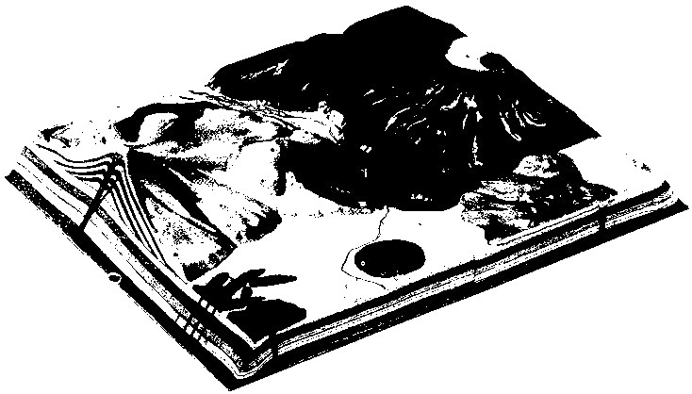
LEGEND
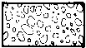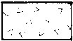
BRECCIA MAGMA SANDSTONE CONGLOMERATE

SHALE LIMESTONE LAVA ASH
Volcanic activity produces many interesting structures. The most dynamic is the volcano itself, and it is important for us to realize that most volcanoes are relatively recent. Notice that all of the volcanic structures on the model occur on the top of the flat sandstone beds. These sedimentary beds extend to the east and west of this model. The volcanic activity began after the sedimentary beds had risen above the level of the sea.
Volcanic activity is cause by great heat below the earth’s surface, melting rock and sending it to the surface through vertical conduits (39). The molten rock and magma travels up through the overlaying layers of rock and forms volcanoes.
This model shows two main types of volcanoes, a composite volcano (28) and a lava type volcano (21). The composite type volcano is made up of alternate layers of lava and volcanic ash or cinders. The depression in the top of the composite volcano is called a crater.
A smaller, more recent volcano (30) is located on the flank of the composite volcano (28). One of the lava flows (31) emerging from the volcano has dammed the river and created a lake (27).
Cinder cones (25), in contrast to the larger volcanoes, are composed almost entirely of cinders. An explosion cone is shown in cross-section. On the southeast corner of the model are several radiating dikes (34).
Downstream from the point where the river is dammed by the lava flow, it emerges onto a sandy flood plain and divides into numerous channels, becoming a braided stream (26). Rain falling on a symmetrical mountain such as a volcano forms a special kind of drainage pattern, called radial drainage (24). The streams radiate from the summit of the mountain. The large lava type volcano (21) has a huge depression known as a caldera (22). In time, this caldera filled with water to form a huge lake. Later, a small cone (23) formed as a result of further volcanic activity. In this manner Crater Lake in Oregon was formed. The cone in Crater Lake is called Wizard Island.
To the southeast of the large lava volcano can be seen an extrusive lava flow (33). This lava flow has poured over the land in a relatively quiet fashion, quite in contrast to the lava flows that originate from the craters of volcanoes. The great Columbia Plateau in eastern Washington and Oregon originated in this manner. Notice that this lava flow has affected the course of the river. In the cross-sections, notice the locations of horizontal masses of lava called sills (36). The done at the intersection of the grids (H & 14) is caused by a laccolith (37). A laccolith is a large subterranean body of magma, which was squeezed between layers of rock causing uplift of the overlying rocks.

Question 1: What evidence do you see on this model that suggests a relationship between faulting and volcanic activity?

Question 2: Describe ways in which volcanoes may be destructive to man and his property.

Question 3: Describe ways in which volcanoes may benefit man.

MODEL 3: FAULT BLOCK MOUNTAINS
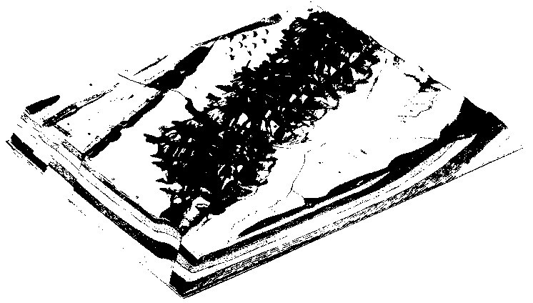

LEGEND

SANDSTONE CONGLOMERATE SHALE

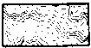
LIMESTONE METAMORPHIC ROCK ASH
This model represents the region where the underlying sedimentary beds have become disturbed by various kinds of faulting, causing block mountain to be formed. The main fault block range (47) has been partially eroded, while the block mountains to the east of the main range have been greatly eroded, and only remnants of the former range remain. The steep fault scarps of the range are on the east of the crest of the range, while the long back slopes of the uplifted blocks are to the west of the crest. Immediately after the faulting, mountain ranges probably appeared singly as great blocks faulted and uplifted on the east and sloping off toward the west. Then the forces of erosion produced steep-walled canyons (52) in the fault blocks. The canyons in the front of the block, which are cut in the fault scarp, have steeper gradients than the ones on the back, which are cut in the more gentle back slopes. In arid climates, land forms tend to be angular, in contrast to the rounded land forms of a moist climate.
The fault scarp now appears as a series of triangular facets (48) and the presence of these triangular facets is further evidence of faulting.
Where each canyon leaves the mountains, a large alluvial fan (46) occurs deposited by the intermittent streams. As a stream comes down the canyon cut into the fault block, its gradient is very steep. Suddenly the gradient decreases, the carrying power also decreases, and material is deposited in the form of an alluvial fan. Fans which have become joined are known as a “bahada.” As erosion reaches a greater stage of maturity, the mountains will become smaller and the bahada slopes larger. The bahada slopes and the basins will become integrated and the mountains will remain islands protruding from the bahada lands.
The several fault block ranges produce enclosed desert basins. The drainage of such a region is not integrated and the streams, which periodically come from the mountains, produce intermittent lakes in the enclosed basins. Since there are no outlets to these lakes, they accumulate great quantities of minerals and salts.
A fault splinter (45) appears at the north edge of the model. This is a newer fault and occurs parallel to the plane of the original fault, producing a fault scarp in the bahada slope. Mineralization often occurs along fault lines and thus mineral deposits may be found in some fault block mountains.
Question 1: Examine the subsurface features on the northeastern corner of the model and note that the conglomerate rock shown in orange forms a ridge, as does the limestone to the east. Also, note that a valley occurs between these two ridges. What would you say about the resistance of erosion of shale, which occupies this valley, compared to conglomerate and limestone?
Question 2: The dotted line around the playa (43) represents an ancient shoreline of this lake. If there were more water in this playa lake at one time than there is at present, how would this relate to the past and present climates of the region?

MODEL 4: ALPINE GLACIATION
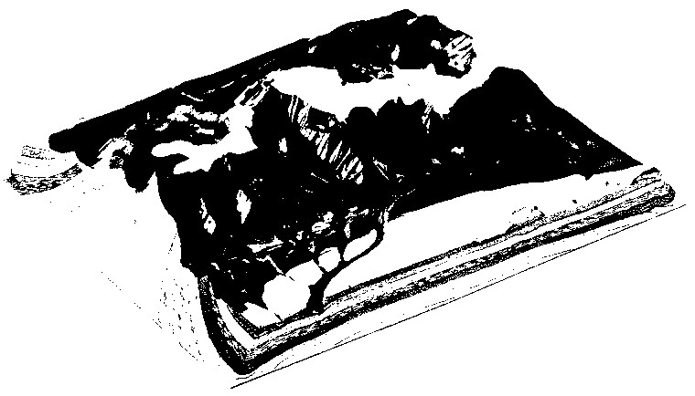
LEGEND

GRANITE METAMORPHIC ROCK SANDSTONE CONGLOMERATE

SHALE LIMESTONE GLACIERS

This model displays features found in a glaciated alpine region. The eastern edge of the model portrays a broad band of arid plains with a canyon cut through the southern end. To the west, hogback ridges have been formed in the foothill regions. Beyond the line of vegetation, or timberline, there is an area of bare rock, which is capped with snow and in some regions with ice of glaciers. Many lakes are evident in the valleys and in the mountain basins, called cirques. At the eastern edge of the mountain range, several longback ridges may be observed.
If we examine the sub-surface geology as depicted on the margins of the model, we will be able to understand how this complex mountain topography was formed. The western edge of the model tells us that the rocks of the western flank of the mountains are sedimentary. The eastern edge also consists of sedimentary beds; however, the sequence of beds on the eastern edge is different from that on the western edge. If we examine the southern and northern edges of the model, we see a large intrusive mass of granite (76) that forms the backbone of the mountain system. Between the granite mass and the sedimentary beds is found a layer of metamorphic rock (77). This model contains examples of the three major rock types: a) igneous rock, represented by the granite; b) metamorphic rock (examples of metamorphic rock are quartzite, schist, marble, and slate), and c) sedimentary rock (example of sedimentary rock are sandstone, shale and limestone).
The most characteristic feature of this mountain range is the sculpturing that has taken place because of the action of alpine glaciers. Glaciers are masses of ice that form in basins and valleys in mountain ranges.
The alpine glaciers shown in this model are but the remnants of a much larger glacial system that sculptured the granite peaks, ridges and valleys of these mountains. The deep U-shaped valleys now partly occupied by vegetation, in times past contained glaciers. Originally, these valleys were V-shaped in cross section. Their U-shaped form today is evidence of the broadening and deepening effect of glacial ice. As the larger glaciers moved down the larger valleys, their greater scouring action cut below tributary valleys. These tributary valleys now above the main valley, are called hanging valleys (58). Isolated cirques are called hanging cirques (63). This mountain range is shown as it would appear in late spring or late fall with snow covering the higher mountain peaks and ridges. The lakes are fed by meltwater from the mountain snows and glaciers.
Question: The majority of the glaciers in the model occupy valleys and cirques facing more to the north than to the south. What explanation can you give that explains this phenomenon?

MODEL 5: DOME MOUNTAINS
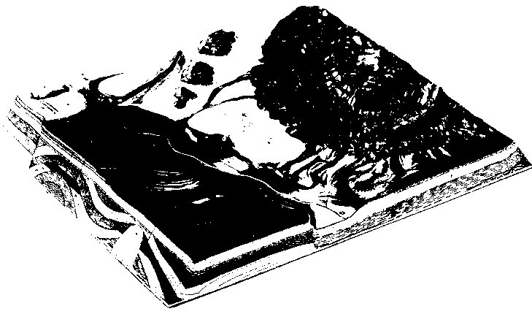

LEGEND

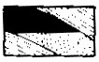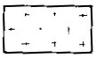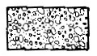
OIL SALT GRANITE GLACIAL TILL

SANDSTONE SHALE LIMESTONE
The mountain mass in the northern part of the model is an example of a dome mountain. Originally, sedimentary rocks arched over the large granite mass. The sedimentary rocks have been eroded from the highest part of the range, leaving a granitic area exposed in the center (79). The dipping sedimentary formations surrounding the granite now appear as ridges around the edge of the dome. The stronger beds such as the sandstones and limestones form hogbacks or cuestas (80). The weaker beds, such as the shales form valleys. This landscape has been created mainly by erosion. The subsequent streams (82) of the region have carried away the eroded material and deposited it on the broad flood plain of the main river valley shown on Model No. 6. The eastern two-thirds of the model is covered with vegetation with exception of the two areas of wind blown sand (83). This suggests higher rainfall in the areas colored green. The western portion of the model depicts arid land lying in the rain shadow of the alpine peaks to the west.
Straight valley canyons, mesas, buttes are the characteristic topographic features to be found in arid regions where the sedimentary strata have been undisturbed.
The southern edge of the model depicts oil deposits beneath the surface. Many years ago, this region was beneath the sea and tiny plants and animals that lived there died and sank to the bottom of the inland sea. As sediments were washed in from the land, the remains of these organisms were trapped in the sediments. As time passed, more and more sedimentary deposits were laid on the top of these organisms. As great pressure compressed the lower layers into rock, a combination of heat, chemical action, and pressure changed the remains of these organisms into droplets of oil and gas. Later, the sedimentary beds were disturbed by pressure from beneath. This pressure produced a series of arches and anticlines. The oil and gas are lighter than the water that saturates the porous rock layer (97). The lighter oil and gas tended to rise to the top of the anticline, and the oil and gas were prevented from going further by a layer of impervious shale, here depicted in green.
A salt dome may also be seen on the south edge of the model. Salt domes are formed by the upward movement of salt from a deeply buried deposit. Here we see how a salt plug has penetrated a shale, a sandstone, and yet another shale bed. An oil trap has been formed on either flank of the salt dome.
Question: Are there any surface features on the model that might indicate an oil-bearing anticline or oil dome?

MODEL 6: CONTINENTAL GLACIATION
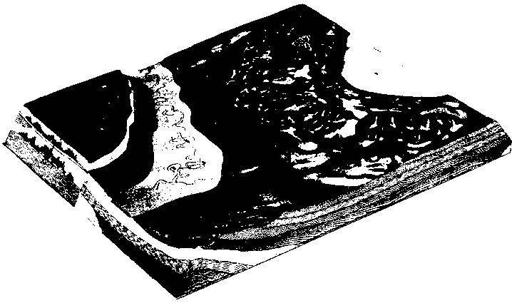
LEGEND

SANDSTONE SHALE LIMESTONE

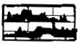
GLACIAL TILL SWAMP CAVERNS
This is a model of a region, which has features resulting from continental glaciation. A large lake fills the basin, which has been carved by one of the main lobes of the continental glacier. This may be seen at the north end of the model. All preglacial rock outcrops have been obscured by the thick till deposits. The glaciated region has undergone little erosion; therefore, the till plain is considered young.
Typical moraine features may be seen on the terminal moraine (105). These include kettles (113) kettle lakes (111) as well as numerous mounds and hummocks. The kettle depressions were created by the melting of isolated blocks of ice left by the retreating glacier; these blocks of ice were buried in the till and when they melted, the overlying till settled, leaving depressions. As esker (109) is a ridge-like deposit of sand and gravel left by a stream which ran in a tunnel in the ice of the glacier.
North of the terminal moraine is a recessional moraine (103). This is a till deposit left during the glacier’s retreat. A group of drumlins (108) may be seen at the northeast end of the model. The steeper ends of the drumlins usually face toward the direction from which the glacier came. South of the terminal moraine all of the topography is unglaciated. Some glacial material has been deposited by stream action on the outwash plain (107).
There is a limestone area in the southwest corner of the model with extensive subterranean caverns. These caverns have been formed by water dissolving the calcium carbonate (limestone). Water running through underground fissures has dissolved caves in the limestone. Where the limestone overlying these caves has collapsed, depressions are formed. Originally, drainage in the limestone area was on the surface, however in a mature region such as this the drainage is subterranean.
The larger river meanders across the broad flood plain created between the glacial outwash and the limestone cliff (121). The river has cut a terrace (114) in the limestone. Several stages in the creation of ox-bow lakes can be seen in the course of the river on this model.

MODEL 7: FOLDED MOUNTAINS

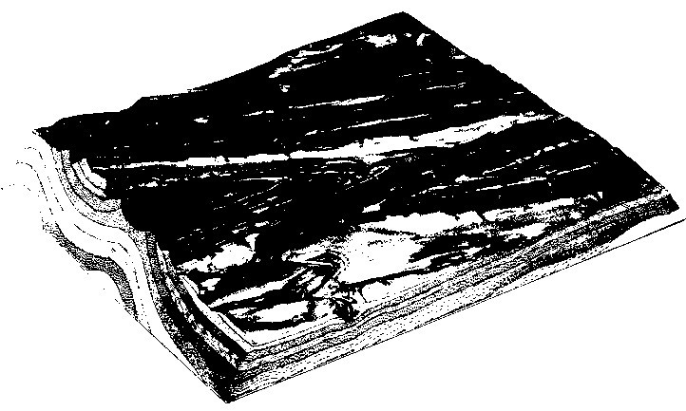
LEGEND

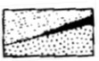

SANDSTONE SHALE LIMESTONE COAL

This model shows a region of folded strata which have formed mountains. The upward folds are anticlines (141) and the downward folds are synclines (142). Anticlines and synclines may be horizontal or may be plunging. An anticline may form a mountain (anticlinal mountain) (126) and a syncline may form a valley (synclinal valley) (130). However, erosion of the folds usually removes the crests of the anticlines, and the more resistant strata of the sides (limbs) of the folds form long mountain ridges, known as homoclinical ridges, but if the fold is plunging, the ridges on either side of an anticline will converge in the direction of the plunge and those of a syncline will diverge in the direction of the plunge.
Continues erosion may further wear down the center of an anticline, reducing the anticline to a lower level than the adjacent synclines, thus forming an anticlinal valley (127). The mountains at the side are now the preserved synclines and form synclinal mountains (129).
The main stream (or streams) crossing the folded region persisted in their course as the folds were uplifted. They now cut across the structure as antecedent streams (not shown on this model). They cross the ridges in narrow valleys called water gaps. Tributaries to the master stream (or streams) draining the region have taken their courses later and these courses are controlled by the structure of the rocks. Those streams, which have valleys cut along the outcrop of weak rocks, between ridges or more resistant rocks, are called subsequent. They usually have straight courses and enter the master stream at right angles. The pattern of these streams is like a trellis, and the pattern is called a trellis drainage pattern.

MODEL 8: COASTAL PLAIN

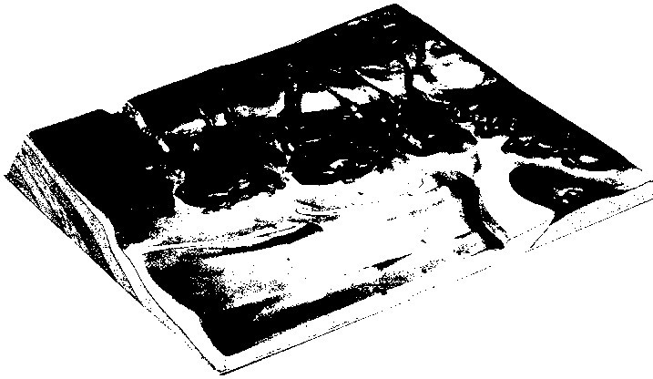

LEGEND

SANDSTONE SHALE LIMESTONE SEDIMENTS

The irregular form of this coastline is caused by its having first been raised so that the river valleys were formed, then it slowly sank drowning the valleys, forming estuaries. A prominent feature shown on the model is the offshore bar (145) which was formed from the land so that incoming waves break in the shallow water some distance offshore. Along the line of the breaking waves sand is stirred up and thrown landward. The sand deposit grows higher and higher by deposition of more sand thru the action of the waves, as well as by sand that is deposited by long shore currents. Sand dunes may form on top of the bar.
After the offshore bar has emerged above the surface of the water, a lagoon is present between the bar and the shoreline. A lagoon, (146) is a sheltered, calm, stretch of water that is frequently used for costal navigation. The rivers that drain the coastal plain and flow into the lagoons bring great quantities of sediments. These sediments are gradually deposited in the lagoon and eventually tend to fill it up.
In the shallow waters of the lagoon, salt marshes are formed. These salt marshes (148) are laced with an intricate pattern of tidal channels in which water level fluctuates with the rising and falling of the tide.
At certain intervals in the offshore bar, inlets (147) occur through which the tide flows. On the landward side of the tidal inlet, a tidal delta may be deposited. Gradually the lagoon tends to fill up with sediments, and fresh water plants begin to invade what was formerly a salt marsh. In this stage of shoreline development, the offshore bar itself is attacked by the waves and driven landward across the lagoon or marsh, leaving a relatively straight coastline.

Question 2: Examine the salt marshes of the west of the offshore bar. Would you expect to find the same kind of organisms living in these salt marshes as in the salt marshes close to the river mouth? Give several reasons for your answer.

Analysis: After careful examination of each geological model, the student takes a short test in which questions are answered and topographical features are identified. To complete the lab report, the student is supposed to take a minimum of three tests, associated to three different geological models.

TESTS: Students, please print out and bring to class at least three tests. They are downloadable from the same website. Answering to more than three tests improves your chance of receiving a good grade. Do NOT forget to bring the test sheets with you when you come in to this lab.

