San Diego Mesa College Name_________________________
Physical Science 101 Lab Report Date __________Time___________
Partners ______________________

TITLE: Altitude-Azimuth Coordinates ______________________________
______________________________
______________________________

Objective: Upon completion of this experiment, you should be able to understand the meaning of the azimuth and altitude system of coordinates, and to “see” the relative distances between planets of the solar system.

Theory: On the earth, the latitude and longitude coordinate system is used to pinpoint any location
on the surface of the globe. In a similar way, astronomers have devised coordinate systems to pinpoint “positions” of the celestial objects on the celestial sphere. In reality, these positions are directions, relative to fixed points or circles, which we think of as being projected on the sky. Two commonly used astronomical coordinate systems are the altitude-azimuth (sometimes abbreviated as “alt-azimuth”) system, and the equatorial system. In this exercise, we will be concerned with the alt-azimuth system.

The reference plane of the alt-azimuth system is simply the horizon of the observer. Its reference direction is the north cardinal point, or “true north.” Every object in the sky has an altitude, expressed as its angle above the horizon in degrees. Objects anywhere on the horizon have an altitude of 0°, while a star at the zenith (straight up) would have an altitude of 90°. If an object is below the horizon, its altitude is negative. Azimuth, the horizontal position of anything in the sky, is also measured in degrees, north being 0°, east 90°, south l80°, and west 270°.
The alt-azimuth (altitude - azimuth) coordinate system, also called the horizon system, is a useful and convenient system for pointing out a celestial object.
One first specifies the azimuth angle, which is the compass heading towards the horizon point lying directly below the object. Azimuth angles are measured eastwardly from North (0 deg azimuth) to East (90 deg), South (180 deg), West (270 deg), and back to North again (360 deg = 0 deg). The four principle directions are called the cardinal points.
Next, the altitude is measured in degrees upward from the horizon to the object. The point directly overhead at 90 deg altitude is called the zenith. The nadir is "down", or opposite the zenith. We sometimes use zenith distance instead of altitude, which is 90 deg minus the altitude.
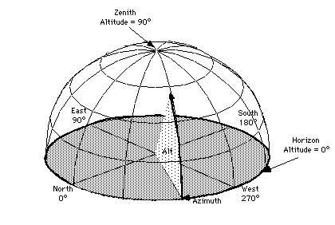
Every observer on Earth has his own separate alt-azimuth system; thus, the coordinates of the same object will differ for two different observers. Furthermore, because the Earth rotates, the altitude and azimuth of an object are constantly changing with time as seen from a given location. Hence, this system can identify celestial objects at a given time and location, but is not useful for specifying their permanent (more or less) direction in space.

Exercises:

- Fill in the blanks on the following table. If a blank space calls for an entry which is indeterminate, indicate this by placing an X there.

FEATURE | AZIMUTH | ALTITUDE
North Cardinal Point | 0° | 0°
South Cardinal Point |  | 0°
 | 90° | 0°
 |  | 90°
Nadir (straight down)
 | 45° | 0°
West Cardinal Point
 | 360° | 0°
 | 0° to 360° | 0°
 | 0° & 180° only | any altitude
 | any azimuth | + 90° to -90°
Southwest Point

- Do the azimuth and altitude of a star remain fixed throughout the day or evening? Explain.
- Can you think of any other disadvantages of the alt-azimuth system?

For the second part of this lab, print out ALL pages from the link provided below (including the table with the relative sizes and distances of the planets), cut the disks representing the planets, and bring everything with you in class.

Using them, we will go outside to build a representation of the solar system.

Use the link:
http://cse.ssl.berkeley.edu/AtHomeAstronomy/activity_10.html

and click on “planet printouts” to go to the site where you will find the scaled planet disks.
Do not forget to bring the table with the relative sizes of the planets, to cut the disks representing the planets, and to bring them in class.

